Exno: 20

Date:

**PERFORMING SOME GIVEN COMMANDS**

AIM:

To create a table bank with the given details.

1. Creating table bank and inserting the given values:

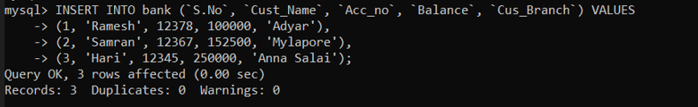

1. Inserting the given values:



1. Simple Select *Select with **where** clause *Select with **comparison operator.**

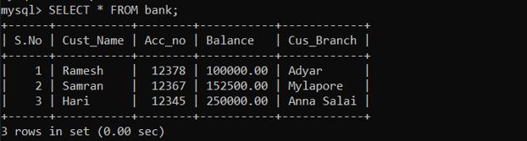

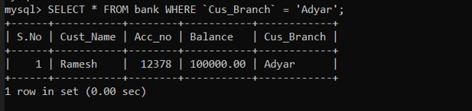

1. Select with between in the field Balance *Update the Cus_Branch in the second row as Pon * find out the maximum balance * Drop the table

